UNITED STATES

SECURITIES AND EXCHANGE COMMISSION

Washington, D.C. 20549

FORM 8-K

CURRENT REPORT

Pursuant to Section 13 or 15(d)
of the Securities Exchange Act of 1934

Date of Report (Date of earliest event reported): October 28, 2026

COHERUS ONCOLOGY, INC.

(Exact name of registrant as specified in its charter)

Delaware | 001-36721 | 27-3615821
(State or other jurisdiction | (Commission | (IRS Employer
of incorporation) | File Number) | Identification Number)

333 Twin Dolphin Drive, Suite 600

Redwood City, CA 94065

(Address of principal executive offices, including Zip Code)

Registrant’s telephone number, including area code: (650) 649-3530

N/A

(Former name or former address, if changed since last report)

Check the appropriate box below if the Form 8-K filing is intended to simultaneously satisfy the filing obligation of the registrant under any of the following provisions:

- Written communications pursuant to Rule 425 under the Securities Act (17 CFR 230.425)

- Soliciting material pursuant to Rule 14a-12 under the Exchange Act (17 CFR 240.14a-12)

- Pre-commencement communications pursuant to Rule 14d-2(b) under the Exchange Act (17 CFR 240.14d-2(b))

- Pre-commencement communications pursuant to Rule 13e-4(c) under the Exchange Act (17 CFR 240.13e-4(c)) Securities registered pursuant to Section 12(b) of the Act:

 |  |  | Trading |  |  | Name of each exchange
Title of each class | ​​​ Symbol(s) ​​​ |  |  |  |  | on which registered
Common Stock, $0.0001 par value per share |  |  | CHRS |  |  | The Nasdaq Global Market

Indicate by check mark whether the registrant is an emerging growth company as defined in Rule 405 of the Securities Act of 1933 (§230.405 of this chapter) or Rule 12b-2 of the Securities Exchange Act of 1934 (§240.12b-2 of this chapter).

Emerging growth company ☐

If an emerging growth company, indicate by check mark if the registrant has elected not to use the extended transition period for complying with any new or revised financial accounting standards provided pursuant to Section 13(a) of the Exchange Act. ☐

Item 7.01 Regulation FD Disclosure.

On October 28, 2026, Coherus Oncology, Inc. (the “Company”) issued a press release announcing the interim clinical data from the TREGCHECK™ development program evaluating tagmokitug, its investigational cytolytic CCR8 antibody, in combination with toripalimab, with or without chemotherapy. A copy of the press release is furnished herewith as Exhibit 99.1 and is incorporated by reference herein.

The information in Item 7.01 of this Current Report on Form 8-K (including Exhibit 99.1) shall not be deemed “filed” for purposes of Section 18 of the Securities Exchange Act of 1934, as amended (the “Exchange Act”), or otherwise subject to the liabilities of that section, nor shall it be deemed incorporated by reference in any filing under the Securities Act of 1933, as amended (the “Securities Act”), or the Exchange Act, except as expressly set forth by specific reference in such a filing.

Item 8.01 Other Events.

On October 28, 2026, the Company announced interim clinical data from the TREGCHECK™ development program evaluating tagmokitug, its investigational cytolytic CCR8 antibody, in combination with toripalimab, with or without chemotherapy. Tagmokitug-based treatment demonstrated encouraging anti-tumor activity across multiple solid tumors, including responses and durable disease stabilization in pretreated and immunotherapy-resistant patients. In evaluable front-line esophageal squamous cell carcinoma (“ESCC”) patients, tagmokitug in combination with toripalimab and chemotherapy demonstrated a confirmed overall response rate (“cORR”) of 75% irrespective of PD-L1 status, and a cORR of 100% in PD-L1 positive patients as of October 14, 2026. Subsequent to the data cutoff date, two additional partial responses were confirmed, increasing the cORR to 89% of the evaluable patient dataset irrespective of PD-L1 status.

Activity and duration of response in second-line ESCC patients, as well as an acceptable and manageable safety profile, support the selected dose and expansion of enrollment in both ESCC cohorts.

Key Interim Findings

The totality of the interim clinical activity, dose-response findings and safety observations support continued development of tagmokitug and expansion of the first-line and second-line ESCC cohorts.

First-Line ESCC: Phase 1b TREGCHECK 102 Cohort C

Study design. Patients with previously untreated advanced or metastatic ESCC received tagmokitug 700 mg plus toripalimab, 5-fluorouracil and cisplatin. The primary endpoint is safety; secondary endpoints include ORR, duration of response, clinical benefit rate and progression-free survival. As of October 14, 2026, 10 patients were safety evaluable and 8 were efficacy evaluable, and enrollment is ongoing. Of the evaluable patient data set:

 | Efficacy Measure | Interim Result | Key Considerations
 | cORR all comers | 75% (6/8) | No PD-1 inhibitors approved in PD-L1-negative
 |  |  | ESCC in the US
 | Post-data-cutoff cORR | 89% (8/9) | Includes confirmation of a prior unconfirmed partial
 |  |  | response (“uPR”) and one newly evaluable patient
 |  |  | with a confirmed partial response (“cPR”)
 | Confirmed ORR in PD-L1 | 100% | US SoC Benchmark (PD-1 + chemo) cORR is
 | positive ESCC |  | 44%-59% for PD-L1 positive ESCC
 | Confirmed complete response | 1 patient | Confirmed at the data cutoff

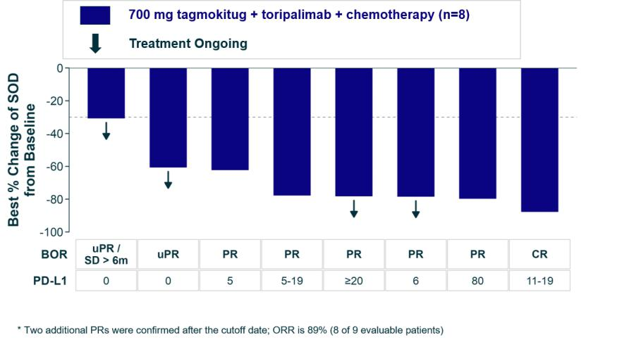

Figure 1. First-line ESCC waterfall plot from TREGCHECK 102 Cohort C. Data as of October 14, 2026

Second-Line ESCC: Phase 1b TREGCHECK 102 Cohort B

Study design. Patients with recurrent or metastatic ESCC who failed first-line systemic chemotherapy with or without a PD-1 inhibitor were randomized 1:1 to tagmokitug 300 mg or 700 mg plus toripalimab. As of October 14, 2026, 17 patients were safety evaluable and 8 (2 in 300 mg and 6 in 700 mg) were efficacy evaluable and enrollment is ongoing. Of the evaluable patient data set:

Efficacy Measure | Interim Result | Key Considerations
Clinical Benefit Rate (“CBR”) in | 33.3% (2/6) | Consistent with immuno-oncology-driven durable
700 mg tagmokitug dose arm |  | stable disease (“SD”)
cORR in 700mg tagmokitug | 16.7% (1/6) | Confirmation of 1 PR and 1 uPR
dose arm
Median Progression-Free | 5.5 months | US SoC Benchmark (chemo) mPFS is ~3.4 months
Survival (“mPFS”) in 700mg
tagmokitug dose arm
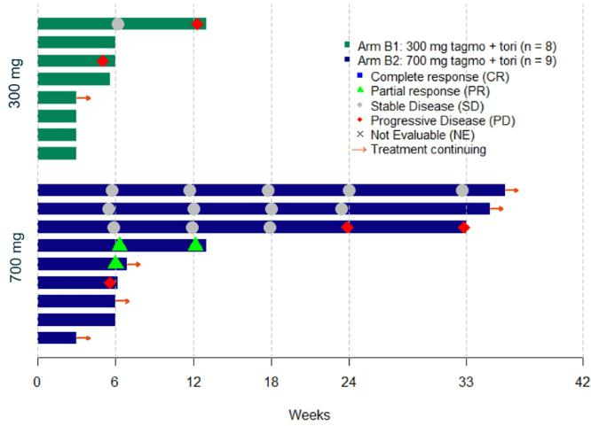

Figure 2. Second-line ESCC swimmer plot by randomized tagmokitug dose. Data as of October 14, 2026

Interim Results in Other Indications

 | Cohort | Population | Interim findings
 | 2L HNSCC | 43 treated; 23 HPV- | In HPV-positive disease across doses, 13.0% cORR (3/23)
 | Two tagmokitug doses | positive efficacy | and 26.1% CBR (6/23);
 | (700 mg and 300 mg) | evaluable | Additional potential enrichment strategy based on Tumor
 | plus toripalimab |  | Immune Regulatory Index (“TIRI”), a tumor-derived CCR8-
 |  |  | containing biomarker score, under evaluation; HPV+ -
 |  |  | TIRI+ patients demonstrated a 45% CBR (5/11).
 | 2L Upper GI: | 40 treated; 33 efficacy | At 700 mg, 4 confirmed PRs among 17 evaluable patient
 | GC/GEJ/EAC | evaluable | data set (23.5% cORR), including 2 PRs in EAC with follow-
 | Two tagmokitug doses |  | up continuing;
 | (700 mg and 300 mg) |  | Clear dose-response;
 | plus toripalimab |  | Demonstrated PD-1 resistance rescue at 700 mg and tumor
 |  |  | shrinkage in PD-1-refractory and naive patients;
 |  |  | Durable clinical benefit with a chemo-free regimen.
 | 4L+ NLM MSS CRC | 20 treated; 17 efficacy | 5.9% cORR and 11.8% CBR, with antitumor activity and
 | 700 mg tagmokitug | evaluable | molecular response (“ctDNA”) observed in a highly
 | dose plus toripalimab |  | refractory, IO-nonresponsive population with follow-up
 |  |  | continuing.
Safety and Tolerability

Tagmokitug demonstrated a manageable safety profile across the TREGCHECK™ clinical program. In 33 patients with monotherapy, no dose-limiting toxicities were observed through the 1200 mg every-three-week dose level, and no Grade 5 treatment-related adverse events were reported.

In more than 120 patients treated with tagmokitug in combination with toripalimab, no new safety signals beyond those associated with PD-1/immune checkpoint inhibitor therapy were identified. Most adverse events were Grade 1 or 2 and resolved, and safety was comparable across tagmokitug dose levels. Among 120 patients treated with tagmokitug plus toripalimab, the overall rate of immune-related adverse events (“irAEs”) was 40% (for all grades), with 20% experiencing Grade 3-5 irAEs. The most commonly reported TRAEs were infusion-related reactions (25.0%), fatigue (19.2%) and rash (15.8%). No Grade 5 treatment-related adverse events were reported.

In the first-line ESCC cohort, 10 patients treated with tagmokitug in combination with toripalimab and chemotherapy demonstrated a manageable safety profile, with no new safety signals or Grade 5 treatment-emergent adverse events observed. Most adverse events were attributed to chemotherapy and the treatment discontinuation rate is similar to the approved regimens for PD-1 inhibitors with chemotherapy.

Tagmokitug is an investigational product candidate and has not been approved by the U.S. Food and Drug Administration or any other regulatory authority. Its safety and efficacy have not been established.

Toripalimab is an investigational product candidate in these indications in the United States.

Clinical Development and Next Steps

Based on the interim findings, the Company plans to expand enrollment in first-line and second-line ESCC and continue to evaluate the durability of response, progression-free survival and biomarker findings across indications as the data mature.

The Company is also advancing tagmokitug in combinations beyond PD-1 inhibition, including a planned study evaluating the safety of tagmokitug with a T-cell engager in mCRPC.

Forward-Looking Statements

The statements in this Current Report on Form 8-K include express or implied forward-looking statements within the meaning of the “safe harbor” provisions of the Private Securities Litigation Reform Act of 1995, Section 27A of the Securities Act, and Section 21E of the Exchange Act about the Company that involve risks and uncertainties relating to future events and the future performance of the Company. Forward-looking statements relate to expectations, beliefs, projections, future plans and strategies, anticipated events or trends and similar expressions concerning matters that are not historical facts. Words such as “will,” “could,” “would,”

“should,” “expect,” “plan,” “anticipate,” “intend,” “believe,” “estimate,” “predict,” “project,” “potential,” “continue,” “future,” “opportunity,” “likely,” “target,” variations of such words, and similar expressions or negatives of these words are intended to identify such forward-looking statements, although not all forward-looking statements contain these identifying words. You can also identify forward-looking statements by discussions of strategy, plans or intentions.

Examples of such forward-looking statements include, but are not limited to, express or implied statements regarding: the development plan for tagmokitug; the potential therapeutic benefits of tagmokitug; the initiation, timing and progress of clinical studies; future data readouts; and the assumptions underlying or relating to such statements. Such forward-looking statements involve substantial risks and uncertainties that could cause the Company’s actual results, performance or achievements to differ significantly from any future results, performance or achievements expressed or implied by the forward-looking statements. Such risks and uncertainties include, among other things, the risks and uncertainties inherent with clinical research and commercialization; the risks and uncertainties of the clinical development and regulatory approval process; risks related to the Company’s ability to increase sales of LOQTORZI or expand LOQTORZI into other indications; the risk that the Company is unable to complete commercial transactions in a timely manner or at all; risks and uncertainties in executing collaboration agreements and other joint ventures, including particular risks of working with international partners; the risk of the Company’s dependence on an ability to raise funds, which may not be available on acceptable terms or at all; the risks and uncertainties of the degree of market acceptance for the Company’s product and product candidates by physicians, healthcare providers and patients; and the risks and uncertainties of litigation. For a further discussion of these and other factors that could cause the Company’s future results to differ materially from any forward-looking statements, see the section entitled “Risk Factors” in the Company’s Quarterly Report on Form 10-Q for the quarter ended June 30, 2026, filed with the Securities and Exchange Commission (the “SEC”) on August 5, 2026, as updated by the Company’s subsequent reports filed with the SEC. All forward-looking statements speak only as of the date of this Current Report on Form 8-K and, except as required by applicable law, the Company has no obligation to update or revise any forward-looking statements contained herein, whether as a result of any new information, future events, changed circumstances or otherwise.

Item 9.01 Financial Statements and Exhibits.

(d) Exhibits

Exhibit |  | ​
No. |  | ​ Description
 | 99.1 |  | Press release dated October 28, 2026
104
 |  |  | Cover Page Interactive Data File (embedded within the Inline XBRL document)

SIGNATURES

Pursuant to the requirements of the Securities Exchange Act of 1934, as amended, the registrant has duly caused this report to be signed on its behalf by the undersigned hereunto duly authorized.

Date: October 29, 2026 | COHERUS ONCOLOGY, INC.
 | By: | /s/ Dennis M. Lanfear
 | Name: | Dennis M. Lanfear
 | Title: | Chief Executive Officer

Exhibit 99.1


Coherus Oncology Announces Compelling Tagmokitug Interim Clinical Data in Esophageal Cancer and Path to Advance Development

-1L ESCC confirmed ORR of 75% irrespective of PD-L1 status, confirmed ORR of 100% for PD-L1- positive, in evaluable patients-

-2L ESCC durable clinical benefit observed with a clear dose-response irrespective of PD-L1 status and in PD-1 refractory patients-

- Anti-tumor activity demonstrated across five indications and over 120 patients, including HPV-positive head and

neck and GI tumors-

- Acceptable and manageable safety profile, with no new safety signals to date supports continued development-

  - Company to host a webcast today at 4:30 pm EDT-

REDWOOD CITY, Calif., October 28, 2026 – Coherus Oncology, Inc. (Nasdaq: CHRS) today announced interim clinical data from the TREGCHECK™ development program evaluating tagmokitug, its investigational cytolytic CCR8 antibody, in combination with toripalimab, with or without chemotherapy. Tagmokitug-based treatment demonstrated encouraging anti-tumor activity across multiple solid tumors, including responses and durable disease stabilization in pretreated and immunotherapy-resistant patients. In evaluable front-line esophageal squamous cell carcinoma (ESCC) patients, tagmokitug in combination with toripalimab and chemotherapy demonstrated a confirmed overall response rate (cORR) of 75% irrespective of PD-L1 status, and a cORR of 100% in PD-L1 positive patients as of October 14, 2026. Subsequent to the data cutoff date, two additional partial responses were confirmed, increasing the cORR to 89% of the evaluable patient dataset.

Activity and duration of response in second-line ESCC patients, as well as an acceptable and manageable safety profile, support the selected dose and expansion of enrollment in both ESCC cohorts.

“The totality of these interim data provides clinical proof of concept for tagmokitug, strengthens our confidence in the selected go-forward dose, and integrated development strategy. We are particularly encouraged by the compelling clinical activity and manageable tolerability observed in ESCC, a disease where significant unmet medical need remains. We look forward to the continued maturation and expansion of these data across both first and second-line ESCC, as we advance the development of tagmokitug for patients with difficult-to-treat cancers,” said Rosh Dias, M.D., Chief Medical Officer, Coherus Oncology.

“These clinical data represent the potential for a meaningful advancement in ESCC, where there is a significant underserved patient population”, said Dan Feng, M.D., Ph.D., Assistant Professor of Medicine, Hematology and Medical Oncology, at the Icahn School of Medicine at Mount Sinai. “Esophageal cancer is a devastating disease, with limited treatment options. I am particularly impressed with the front-line response rate observed with the tagmokitug combination with a PD-1 inhibitor and chemotherapy. I am encouraged by the manageable and acceptable safety profile observed with tagmokitug in combination with toripalimab with and without chemotherapy.”

“This encouraging clinical evidence supports our strategy of targeting CCR8-positive regulatory T cells to overcome immune resistance in cancer, and underscores Coherus Oncology’s scientific leadership in the emerging field of CCR8 Treg depletion,” said Denny Lanfear, Chief Executive Officer of Coherus Oncology. “Importantly, the strength of the

emerging ESCC data provides a clear and efficient path for advancing the development of tagmokitug in esophageal cancer across both indications. Toripalimab is already established as a first-line treatment for ESCC in ex-US major markets, including Europe and China. Given the significant burden of this disease globally, particularly in Asia, we believe these results further strengthen the strategic and global development opportunity for tagmokitug.”

Key Interim Findings

The totality of the interim clinical activity, dose-response findings and safety observations support continued development of tagmokitug and expansion of the first-line and second-line ESCC cohorts.

First-Line ESCC: Phase 1b TREGCHECK 102 Cohort C

Study design. Patients with previously untreated advanced or metastatic ESCC received tagmokitug 700 mg plus toripalimab, 5-fluorouracil and cisplatin. The primary endpoint is safety; secondary endpoints include ORR, duration of response, clinical benefit rate and progression-free survival. As of October 14, 2026, 10 patients were safety evaluable and 8 were efficacy evaluable, and enrollment is ongoing. Of the evaluable patient data set:

Efficacy Measure | Interim Result | Key Considerations
cORR all comers | 75% (6/8) | No PD-1 inhibitors approved in PD-L1-negative
 |  | ESCC in the US
Post-data-cutoff cORR | 89% (8/9) | Includes confirmation of a prior unconfirmed
 |  | partial response (uPR) and one newly
 |  | evaluable patient with a confirmed partial
 |  | response (cPR)
Confirmed ORR in PD-L1 | 100% | US SoC Benchmark (PD-1 + chemo) cORR is
positive ESCC |  | 44%-59% for PD-L1 positive ESCC
Confirmed complete | 1 patient | Confirmed at the data cutoff
response
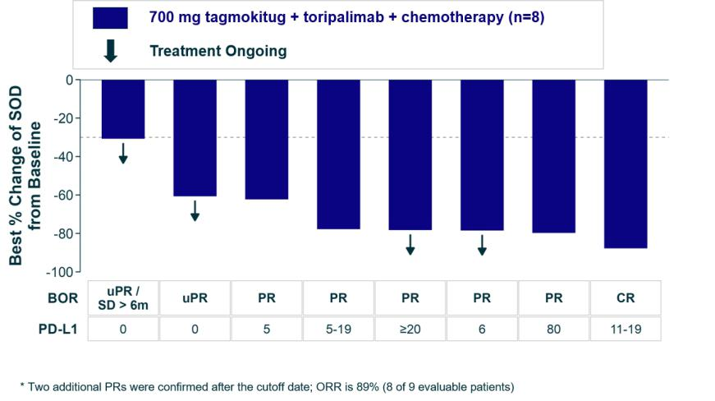

Figure 1. First-line ESCC waterfall plot from TREGCHECK 102 Cohort C. Data as of October 14, 2026 Second-Line ESCC: Phase 1b TREGCHECK 102 Cohort B

Study design. Patients with recurrent or metastatic ESCC who failed first-line systemic chemotherapy with or without a PD-1 inhibitor were randomized 1:1 to tagmokitug 300 mg or 700 mg plus toripalimab. As of October 14, 2026, 17 patients were safety evaluable and 8 (2 in 300 mg and 6 in 700 mg) were efficacy evaluable and enrollment is ongoing. Of the evaluable patient data set:

Efficacy Measure | Interim Result | Key Considerations
Clinical Benefit Rate (CBR) in | 33.3% (2/6) | Consistent with immuno-oncology-driven
700 mg tagmokitug dose arm |  | durable stable disease (SD)
cORR in 700mg tagmokitug | 16.7% (1/6) | Confirmation of 1 PR and 1 uPR
dose arm
Median Progression-Free | 5.5 months | US SoC Benchmark (chemo) mPFS is ~3.4
Survival (mPFS) in 700mg |  | months
tagmokitug dose arm
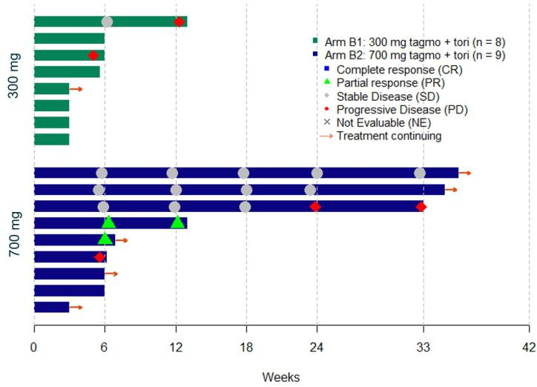

Figure 2. Second-line ESCC swimmer plot by randomized tagmokitug dose. Data as of October 14, 2026

Interim Results in Other Indications

Cohort | Population | Interim findings
2L HNSCC | 43 treated; 23 HPV- | In HPV-positive disease across doses, 13.0% cORR
Two tagmokitug | positive efficacy | (3/23) and 26.1% CBR (6/23);
Two tagmokitug | evaluable
doses (700 mg and | evaluable | Additional potential enrichment strategy based on
300 mg) plus |  | Tumor Immune Regulatory Index (TIRI), a tumor-
toripalimab |  | derived CCR8-containing biomarker score, under
 |  | evaluation; HPV+ - TIRI+ patients demonstrated a
 |  | 45% CBR (5/11).
2L Upper GI: | 40 treated; 33 efficacy | At 700 mg, 4 confirmed PRs among 17 evaluable
GC/GEJ/EAC | evaluable | patient data set (23.5% cORR), including 2 PRs in
Two tagmokitug |  | EAC with follow-up continuing;
doses (700 mg and |  | Clear dose-response;
300 mg) plus |  | Demonstrated PD-1 resistance rescue at 700 mg and
toripalimab |  | Demonstrated PD-1 resistance rescue at 700 mg and
toripalimab |  | tumor shrinkage in PD-1-refractory and naive patients;
 |  | Durable clinical benefit with a chemo-free regimen.

4L+ NLM MSS CRC | 20 treated; 17 efficacy | 5.9% cORR and 11.8% CBR, with antitumor activity
700 mg tagmokitug | evaluable | and molecular response (ctDNA) observed in a highly
700 mg tagmokitug |  | refractory, IO-nonresponsive population with follow-up
dose plus |  | refractory, IO-nonresponsive population with follow-up
dose plus |  | continuing.
toripalimab |  | continuing.

Safety and Tolerability

Tagmokitug demonstrated a manageable safety profile across the TREGCHECK™ clinical program. In 33 patients with monotherapy, no dose-limiting toxicities were observed through the 1200 mg every-three-week dose level, and no Grade 5 treatment-related adverse events were reported.

In more than 120 patients treated with tagmokitug in combination with toripalimab, no new safety signals beyond those associated with PD-1/immune checkpoint inhibitor therapy were identified. Most adverse events were Grade 1 or 2 and resolved, and safety was comparable across tagmokitug dose levels. Among 120 patients treated with tagmokitug plus toripalimab, the overall rate of immune-related adverse events (irAEs) was 40% (for all grades), with 20% experiencing Grade 3-5 irAEs. The most commonly reported TRAEs were infusion-related reactions (25.0%), fatigue (19.2%) and rash (15.8%). No Grade 5 treatment-related adverse events were reported.

In the first-line ESCC cohort, 10 patients treated with tagmokitug in combination with toripalimab and chemotherapy demonstrated a manageable safety profile, with no new safety signals or Grade 5 treatment-emergent adverse events observed. Most adverse events were attributed to chemotherapy and the treatment discontinuation rate is similar to the approved regimens for PD-1 inhibitors with chemotherapy.

Tagmokitug is an investigational product candidate and has not been approved by the U.S. Food and Drug Administration or any other regulatory authority. Its safety and efficacy have not been established.

Toripalimab is an investigational product candidate in these indications in the United States.

Clinical Development and Next Steps

Based on the interim findings, Coherus plans to expand enrollment in first-line and second-line ESCC and continue to evaluate the durability of response, progression-free survival and biomarker findings across indications as the data mature.

Coherus is also advancing tagmokitug in combinations beyond PD-1 inhibition, including a planned study evaluating the safety of tagmokitug with a T-cell engager in mCRPC.

Webcast Information

When: Wednesday, October 28, 2026, from 4:30 p.m. to 6:00 p.m. Eastern Daylight Time.

To access the webcast, please pre-register through the following link to receive dial-in information and a personal

PIN to access the live call: https://register-conf.media-

server.com/register/BI40122fadb7e849969b28a667a784d035.

Webcast: https://edge.media-server.com/mmc/p/wygfpdac.

A live and archived webcast will be available on the “Investors” section of the Coherus website and accompanying materials will be available after the webcast at https://investors.coherus.com/events-presentations.

Please log in approximately 15 minutes before the start of the webcast to ensure a timely connection.

Disclosure Information

Coherus uses the https://investors.coherus.com website as a means of disclosing material non-public information and for complying with its disclosure obligations under Regulation FD.

About Tagmokitug

Tagmokitug is an investigational monoclonal antibody that selectively targets CCR8, a receptor highly enriched on regulatory T cells within the tumor microenvironment. Tagmokitug is currently being evaluated in Phase 1b/2a clinical trials (TREGCHECK™ 101: NCT05635643; TREGCHECK™ 102: NCT06657144) in patients with solid tumors in combination with the PD-1 inhibitor toripalimab and chemotherapy. It is part of Coherus Oncology’s next-generation immunotherapy pipeline being evaluated across multiple solid tumor settings.

About Coherus Oncology

Coherus Oncology is a fully integrated commercial-stage innovative oncology company with an approved next-generation programmed death receptor-1 (“PD-1”) inhibitor, LOQTORZI® (toripalimab-tpzi), and a pipeline that includes two mid-stage clinical candidates targeting liver, prostate, head and neck, colorectal and other cancers. The Company’s strategy is to grow sales of LOQTORZI in R/M Nasopharyngeal Carcinoma and advance the development of its two pipeline candidates in combination with LOQTORZI and through strategic partnerships.

Coherus’ innovative oncology pipeline includes multiple antibody immunotherapy candidates focused on enhancing the innate and adaptive immune responses to enable a robust antitumor response and improve outcomes for patients with cancer. Tagmokitug is a highly selective cytolytic anti-CCR8 antibody currently in Phase 1b/2a studies in patients with advanced solid tumors; including head and neck squamous cell carcinoma, colorectal cancer, gastric, gastroesophageal junction, esophageal adenocarcinoma and esophageal squamous cell carcinoma. Casdozokitug is a novel IL-27 antagonistic antibody currently being evaluated in a Phase 2 study in patients with first-line hepatocellular carcinoma.

LOQTORZI® is a registered trademark of Coherus Oncology, Inc.

©2026 Coherus Oncology, Inc. All rights reserved.

Forward-Looking Statements

Except for the historical information contained herein, the matters set forth in this presentation and any accompanying commentary from the management of Coherus Oncology, Inc. (“Coherus”) are forward-looking statements within the meaning of the “safe harbor” provisions of the Private Securities Litigation Reform Act of 1995. Forward-looking statements contained in this presentation may be identified by the use of words such as “anticipate,” “may,” “will,” “should,” “expect,” “could,” “intend,” “project,” “target,” “estimate,” “predict,” or “potential” or the negative of these terms or other similar expressions. These statements include, but are not limited to statements about the development plan for tagmokitug; ability of any of Coherus’s pipeline product candidates to be first-to-market, first-to-data or first in-class or best in class; the initiation, timing and progress of preclinical and clinical studies; future data readouts or catalysts based on the clinical trials of Coherus; market size, market value, addressable market or opportunity and the number of patients or incidence for particular indications; standard of care expectations; future collaborations; the degree of unmet need for particular indications; and the assumptions underlying or relating to such statements.

Such forward-looking statements involve substantial risks and uncertainties that could cause Coherus’s actual results, performance or achievements to differ significantly from any future results, performance or achievements expressed or implied by the forward-looking statements. Such risks and uncertainties include, among other things, the risks and uncertainties inherent with clinical research and commercialization; the risks and uncertainties of the clinical development and regulatory approval process; risks related to Coherus’s ability to increase sales of LOQTORZI or expand LOQTORZI into other indications; the risk that Coherus is unable to complete commercial transactions in a timely manner or at all; risks and uncertainties in executing collaboration agreements and other joint ventures, including particular risks of working with international partners; the risk of Coherus’s dependence on an ability to raise funds, which may not be available on acceptable terms or at all; the risks and uncertainties of the degree of market acceptance

for Coherus’s product and product candidates by physicians, healthcare providers and patients; and the risks and uncertainties of litigation. For a further discussion of these and other factors that could cause Coherus’s future results to differ materially from any forward-looking statements see the section entitled “Risk Factors” in Coherus’s Quarterly Report on Form 10-Q for the quarter ended June 30, 2026, filed with the Securities and Exchange Commission (“SEC”) on August 5, 2026, as updated by Coherus’s subsequent reports filed with the SEC. Any forward-looking statements speak only as of the date of this presentation and are made based on the current plans, estimates, good faith beliefs and judgments of Coherus management, and the reader is cautioned not to rely on any forward-looking statements made by Coherus. Unless required by law, Coherus is not under any duty and undertakes no obligation to publicly update or revise any forward-looking statement to reflect changes in underlying assumptions or factors, of new information, data or methods, future events or other changes. Coherus’s past performance should not be considered to be a guarantee of future results.

Coherus Oncology Contact Information:

For Investors:

Carrie Graham
Vice President, Investor Relations & Advocacy

IR@coherus.com

